KENDRIYA VIDYALAYA TAMENGLONG SUMMATIVE ASSESMENT- I
(2016-17)

Class – IV Subject – EVS Date -----------------

Name ----------------------------- Roll no. -----------------------

Competencies | Observation & Reporting | Identification & Classification | Discovery of facts | TOTAL
Grade Obtained

Signature of Invigilator___________ Signature of Checker ___________

OBSERVATION $ REPORTING

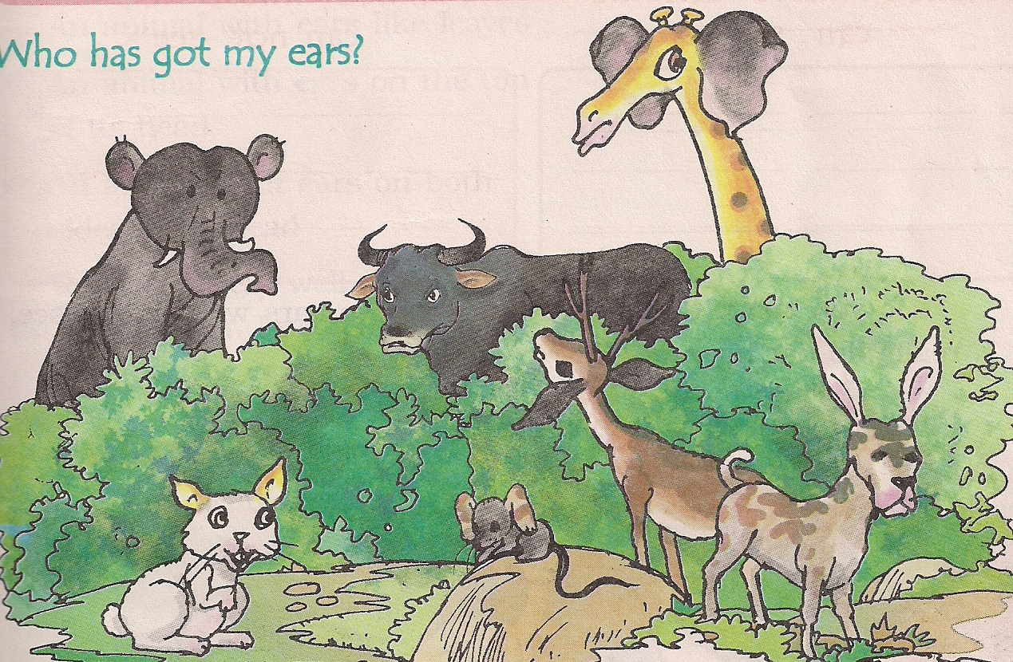

- The artist have drawn wrong years on the heads of the animals. Give the correct ears to the animals in the space given below:

Rat ------------------------------------
Elephant -------------------------------------
Giraffe -------------------------------------
Mouse -------------------------------------
Dog -------------------------------------

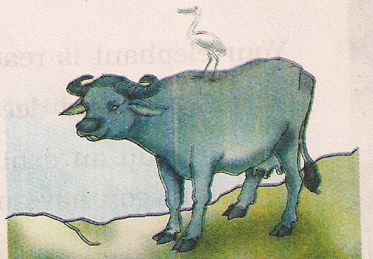

2.(a) Name the bird which is riding:-
------------------------------------------
(b) What do you think the bird is sitting on the buffalo?
----------------------------------------------------------------------------------------------------------------------------------------------------------

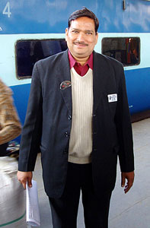
3.Identify this helper in the Railway Station:-

---------------------------------

4. An open box made of wood is called ----------------------------

5.Why do we need bridges?
Ans. ----------------------------------------------------------------------------------------------------------------------------------------------------
6. How many players in kabaddi?
Ans. ---------------------------------------------------------------------
7. How did Khejadli village get its name?
Ans. ---------------------------------------------------------------------------------------------------------------------------------------------------------------------------------------------------------------------------------
8. Why was there smoke and noise at the level crossing?
Ans. ---------------------------------------------------------------------------------------------------------------------------------------------------------------------------------------------------------------------------------
9. What are some of the things that are sold at railway stations?
Ans. ---------------------------------------------------------------------------------------------------------------------------------------------------10. Name the different kinds of transport.
Ans. Names Draw any one
- ________________
- ________________
- ________________
- ________________

IDENTIFICATION $ CLASSIFICATION

1.Match the animals shown here with the pictures of their skins. Make the correct pattern on the skin on the picture of any two animals

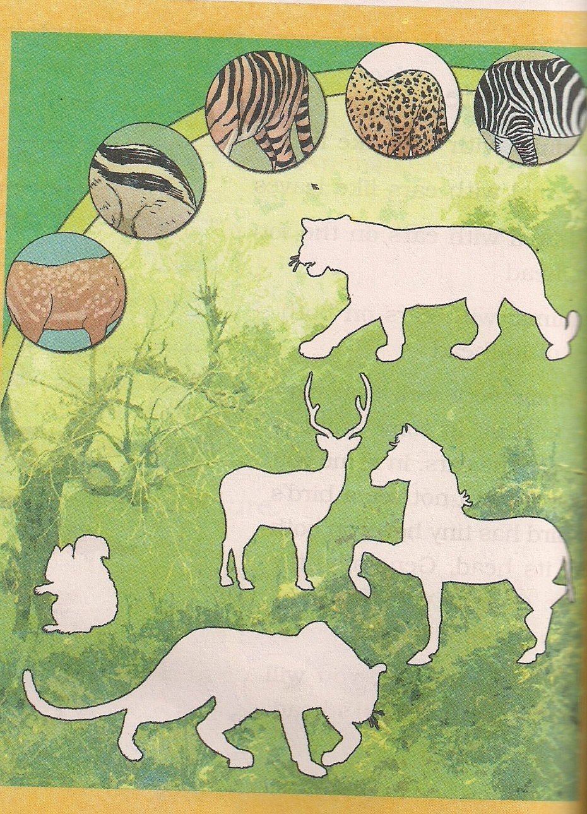
2. The------------- was used by people to cross the water and reach the other side. (Bus / Ferry)
3. Who was the best friend of Omana? (Radha / Amrita)
-----------------------------------------------------------------------------
4. How many legs does an ant have?
Ans. ----------------------------------------------------------------------
5. Do fruits grow on the tree?
Ans. ---------------------------------------------------------------------
6. Every child has a------------ to free education up to class VIII.
(Right/ Duty)
7. Omana saw many types of vehicles at the level crossing. Write the name.
Ans. -------------------------------------------------------------------------------------------------------------------------------------------------------------------------
8. What did Omana see out of the window?
Ans. ----------------------------------------------------------------------------------------------------------------------------------------------------------------------------------------------------------------------------------------------------------------------

9. Who is Karnam Malleshwari?
Ans. ----------------------------------------------------------------------------------------------------------------------------------------------------------------------------
10. There is a great excitement in Nimmi’s family. She has a new baby----------------. (Sister / Brother)
11.Write the functions of the bees
- Queen bee:---------------------------------------------------------------------------------------------------------------------------------------------------
- Worker bee:---------------------------------------------------------------------------------------------------------------------------------------------------
12.Find out in which states these languages are spoken.
Language | State
Malayalam
Konkani
Marathi
Gujarati

DISCOVERY OF FACTS

1. Put tick(√ ) or cross(X) against each statement.
1. Plants and animals can survive without us. ( )
2. Mother’s mother is called Dadi maa ( )
3. The tiger is our National animal. ( )
4. An elephant does not has hair on its skin. ( )
5. The oldest female is the leader of the herd. ( )

2. Which animals do we use for riding?
Ans. 1. -------------------------- 2. -----------------------------
3. Where did Anita live?
Ans. ----------------------------------------------------------------------------------------------------------------------------------------------------

4. Name the two animals whose ears can be seen.
Ans. ------------------------------- 2. ---------------------------------
5.Explain the following terms:
(a) Trolley --------------------------------------------------------------------------------------------------------------------------------------------------------------------------------------------------------------------------
(b) Vallam -------------------------------------------------------------------------------------------------------------------------------------------------------------------------------------------------------------------------
(c) Jugad ------------------------------------------------------------------------------------------------------------------------------------------------------------------------------------------------------------------------------
6. Write the names of two flowers used :
(a) for making medicines ------------------------------------------------------------------------------------------------------------
(b) for making garlands ---------------------------------------------------------------------------------------------------------------------------
7. Draw a picture of a flower and label all its parts.

